## Working with Design Manager

**Lab Time**: 45 minutes

**Lab Folder**: C:\Student\Modules\DesignManager\Lab

**Lab Overview**: In this lab you will get hands-on experience using the Design Manager.

### Lab Setup: Change Site and System Master Page back to Seattle

This lab will walk through the Design Manager, and how to brand a SharePoint site using it. Before starting this lab, please change the site and system pages back to the seattle master.

1. Go to Wingtip’s publishing sites (<http://www.wingtip.com>) in your browser.
2. **In your web browser, go to Site Settings menu and select Site Settings.**

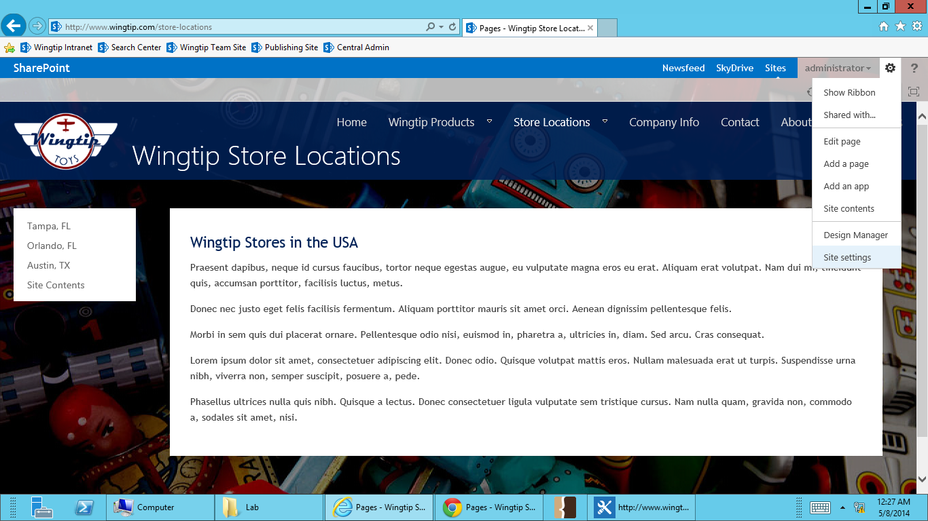

1. **On the Site Settings page, select Master Page under Look and Feel.**

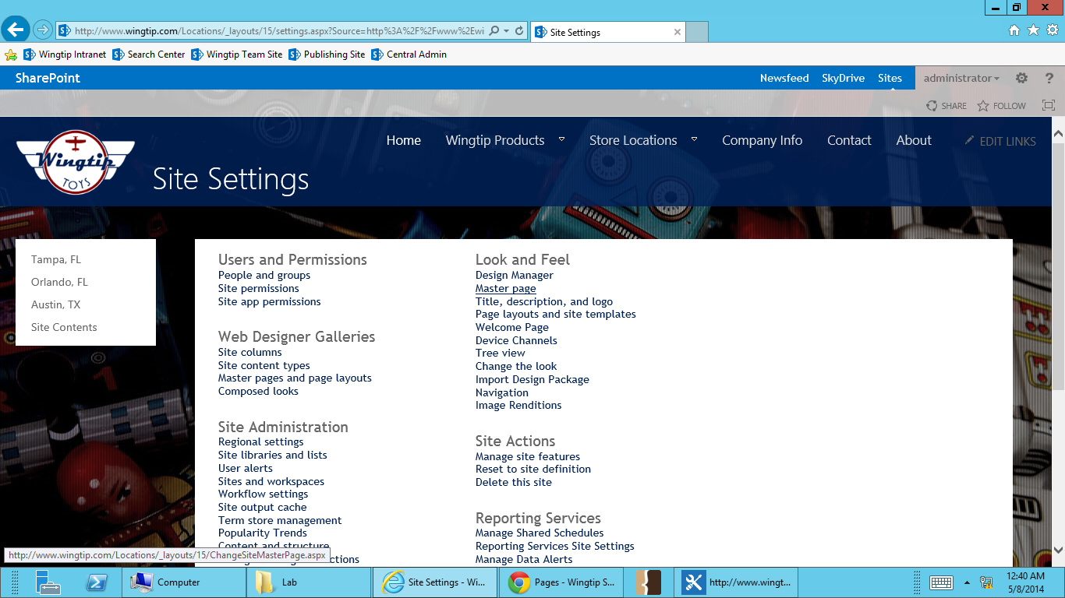

1. Change both site and system master page settings to use the **seattle** master. Be sure to check the checkbox below each master page selector to reset all subsites to use the new master pages settings. **Select OK**.

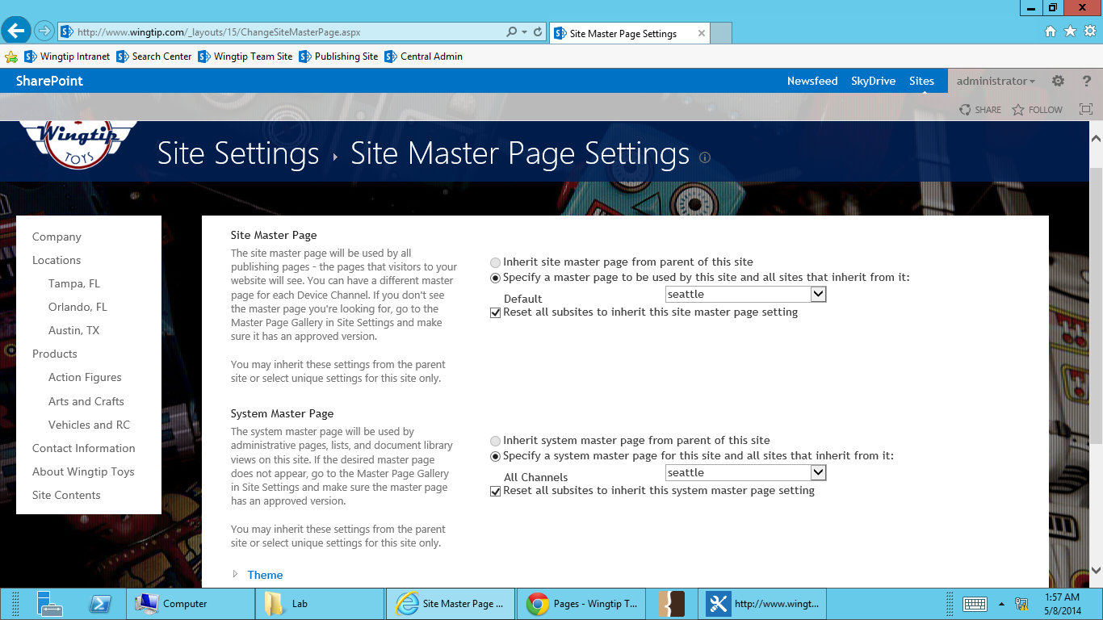

### Exercise 1: Mapping the Master Page Gallery

In this exercise you will map the SharePoint Master Page Gallery as a network drive

1. Go to Wingtip’s publishing sites (<http://www.wingtip.com>) in your browser.
2. Select the **Site Actions** menu in the top right, and go to **Design Manager**.

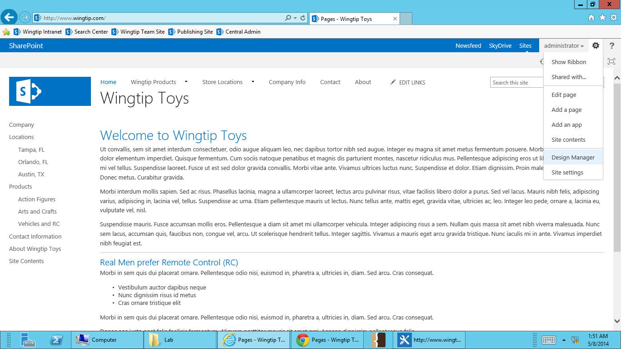

1. Select Step 3 – **Upload Design Files.** This step provides the location of the master page gallery.

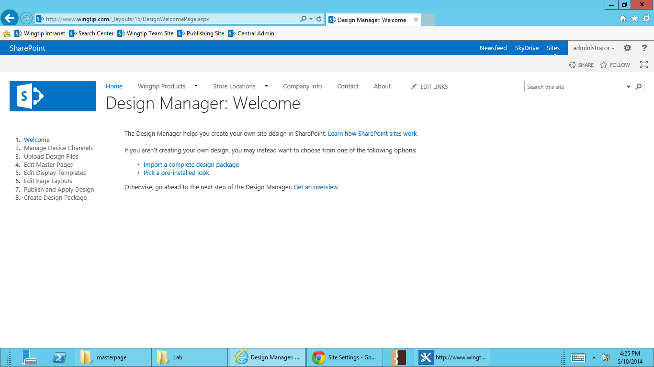

1. Select and copy the path to the master page gallery.

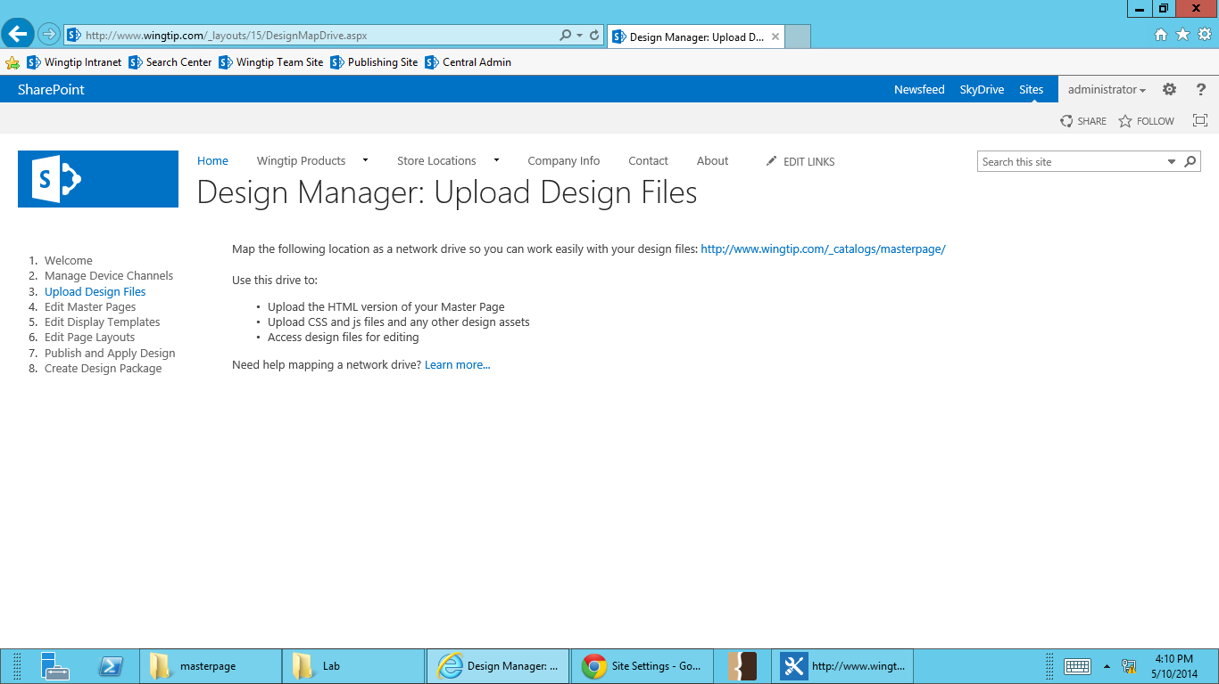

1. On your PC, go to your Desktop. Right click on **Computer**. Select **Map Network Drive**.

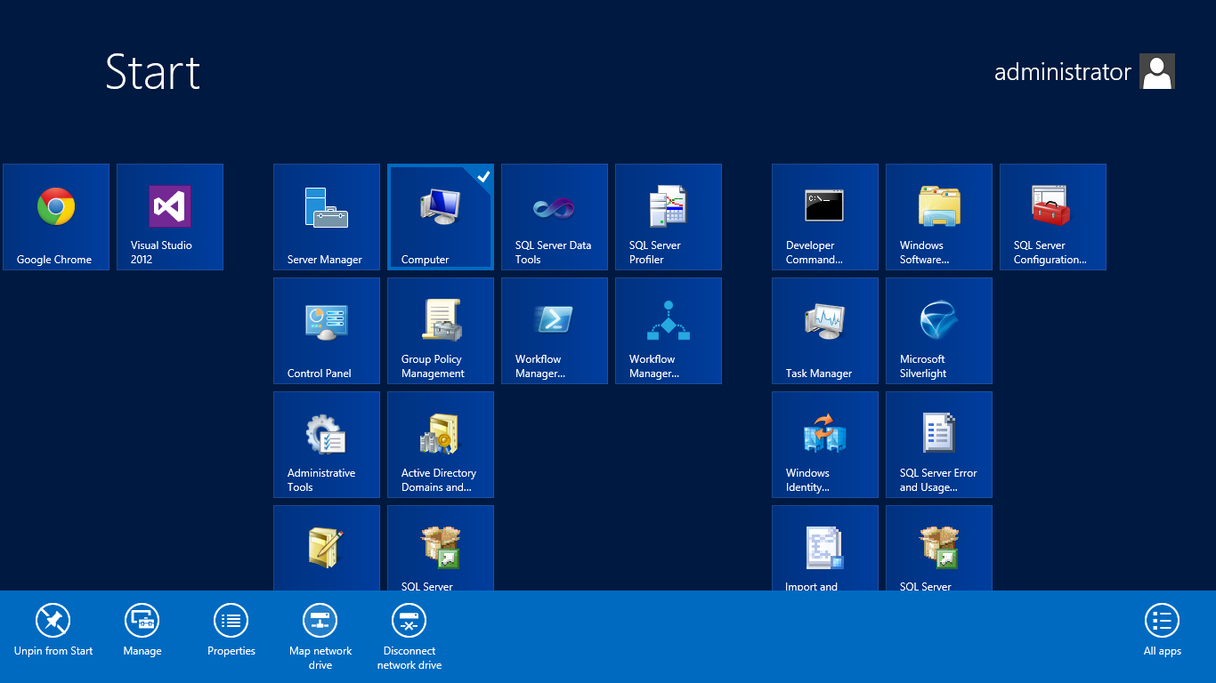



1. Select drive letter Z and paste in the URL for the Master Page Gallery into the folder field. Select **Finish**.

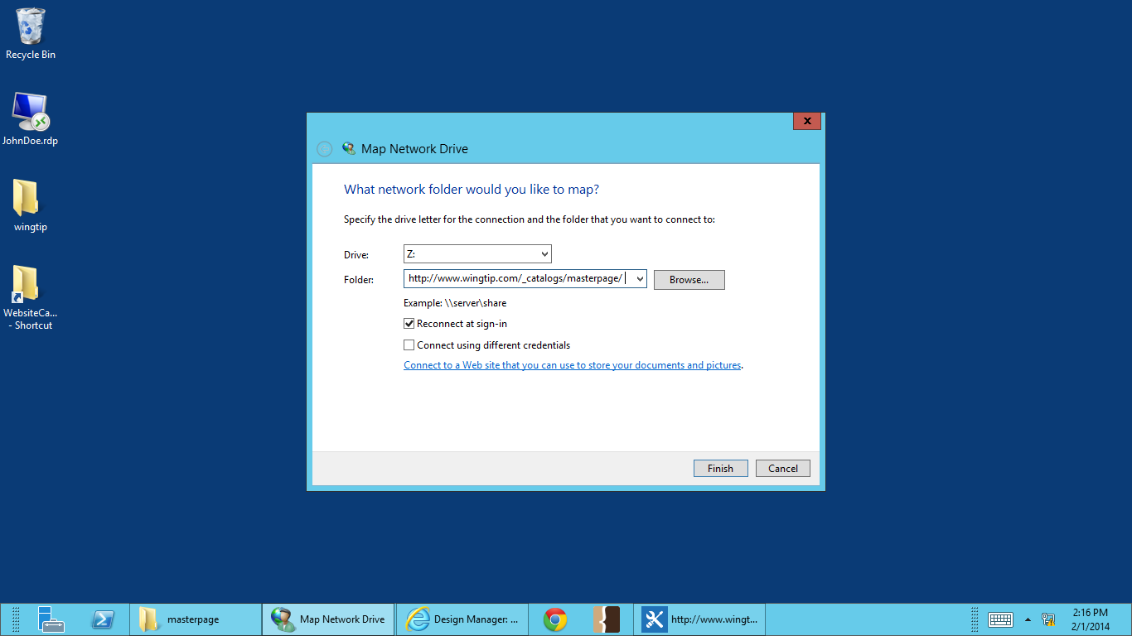

1. Enter in Wingtip user credentials when prompted.
2. You will now be able to explore and work with the master page gallery without having to use SharePoint Designer.

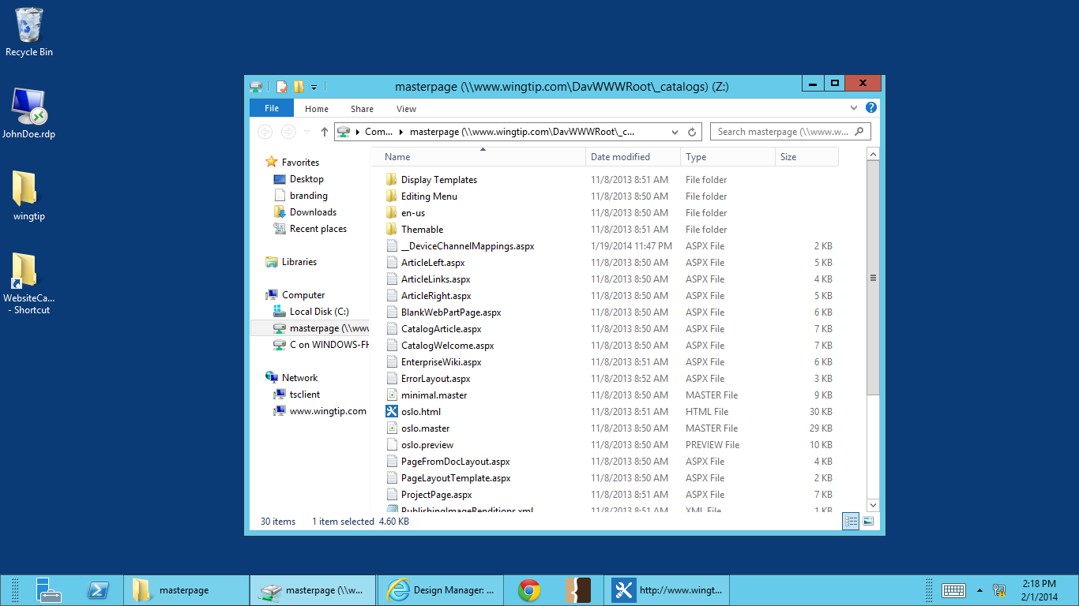

Be cautious when working in your mapped drive. Keep in mind that you are working on your SharePoint server. Any accidental deletes or drag-and-drops will immediately affect that change in the system.

### Exercise 2: Upload brand assets to the Master Page Gallery

**In this exercise you will upload your brand assets (html, css, imagery) to the master page gallery.**

1. **On your PC, go to Computer.**
2. **Open your mapped master page gallery drive.**

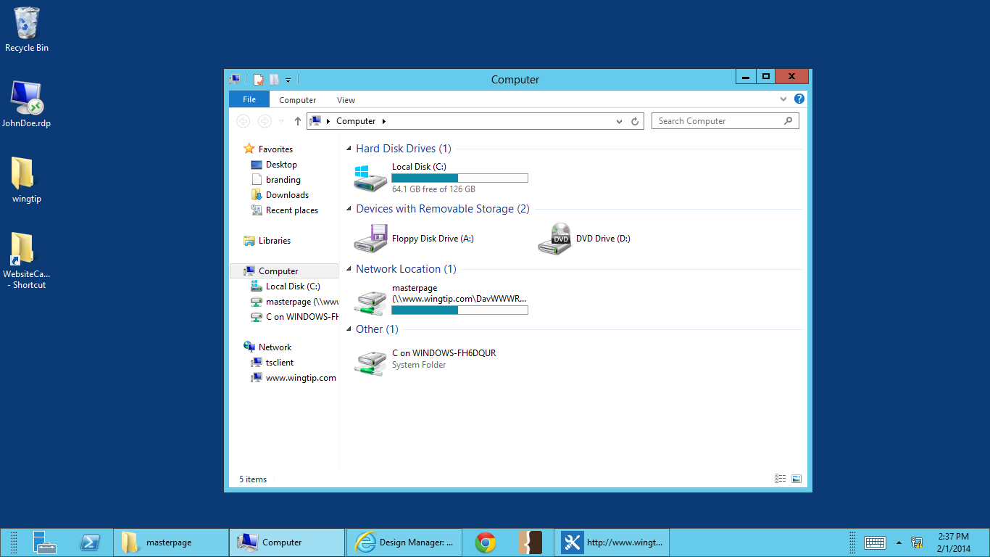

1. **Go back to your desktop and open the wingtip folder.**
   1. **This folder holds your HTML, CSS and image branding assets.**
2. **Drag and drop the files in the lab folder (Austin folder, about.html, austin.html) into the master page gallery.**

**.** 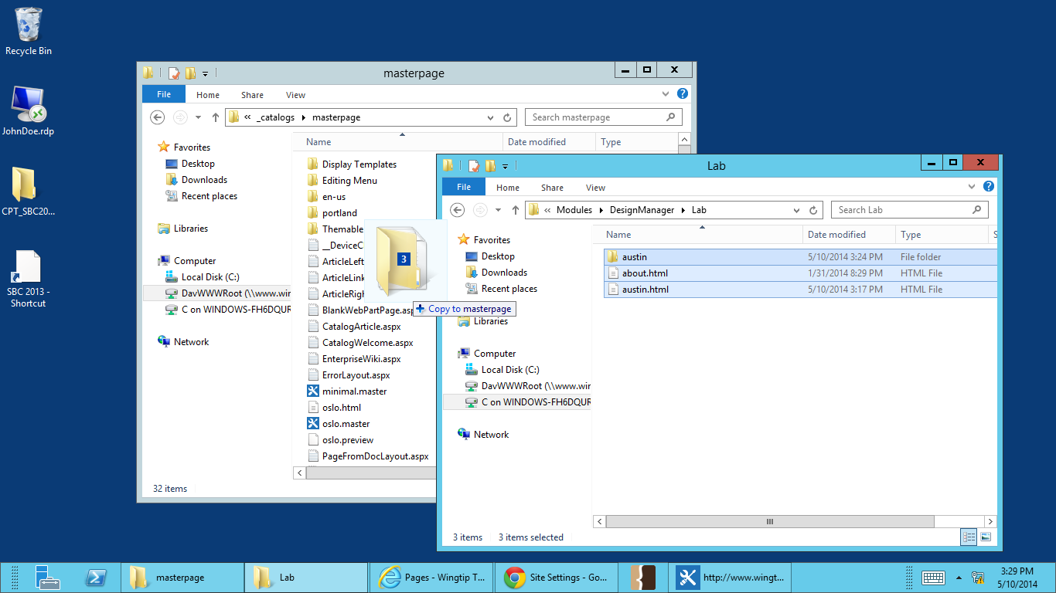

1. **Back in your browser, go to Site Actions -> Site Setting.**

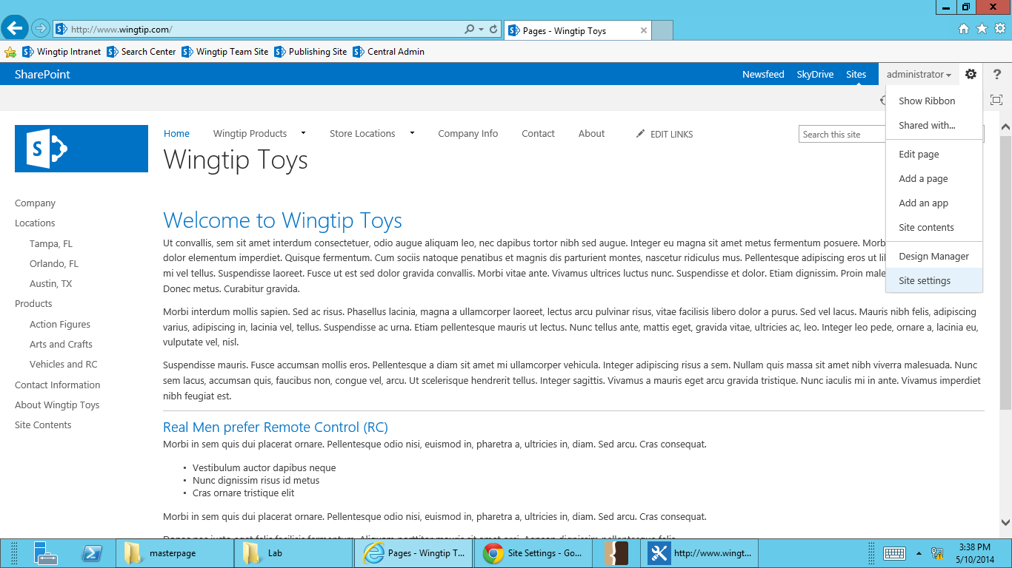

1. **Under Web Designer Galleries, select Master pages and page layouts.**

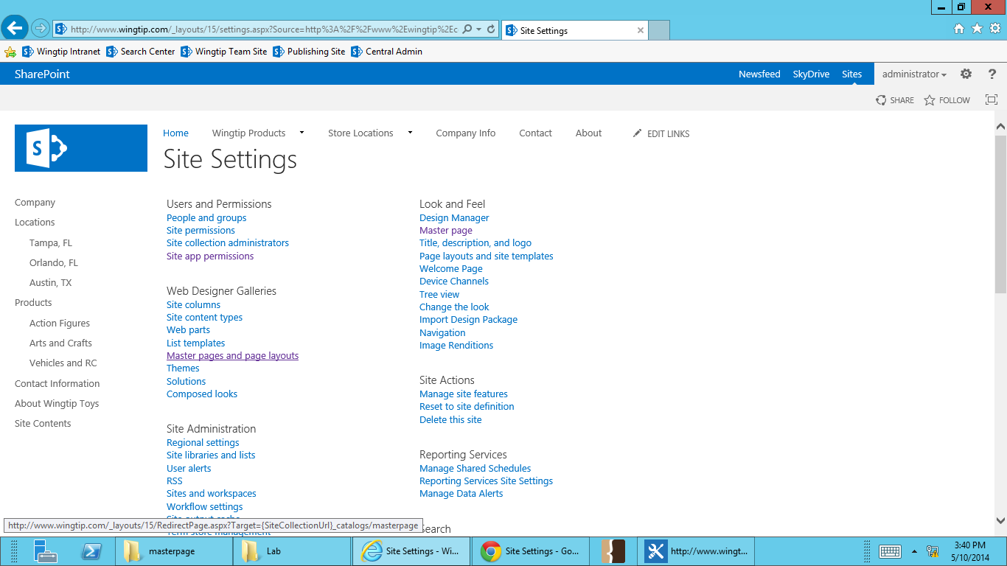

1. **You’ll see the assets you copied into the mapped SharePoint drive are the master page gallery.**

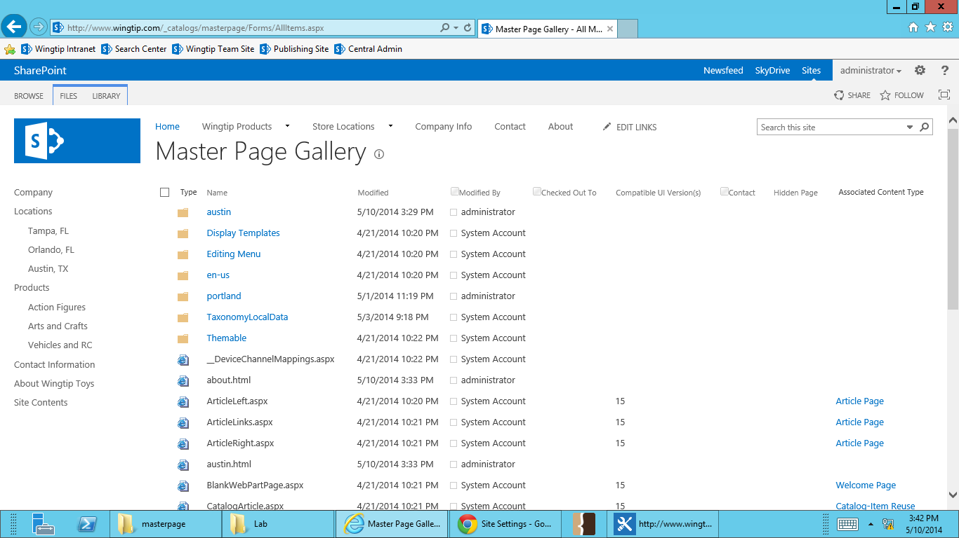

**Your wingtip branding assets have been loaded onto your SharePoint server and can now be used to create your master page and SharePoint brand.**

### Exercise 3: Converting an HTML file to a Master Page (.master)

**In this exercise you will convert the html file you uploaded in the previous exercise to a master page.**

1. Go to Wingtip’s publishing sites (<http://www.wingtip.com>) in browser.
2. Select the **Site Actions** menu in the top right, and go to **Design Manager**.



1. **Select Step 4 – Edit Master Pages.**



1. **Select Convert an HTML file to a SharePoint master page.**

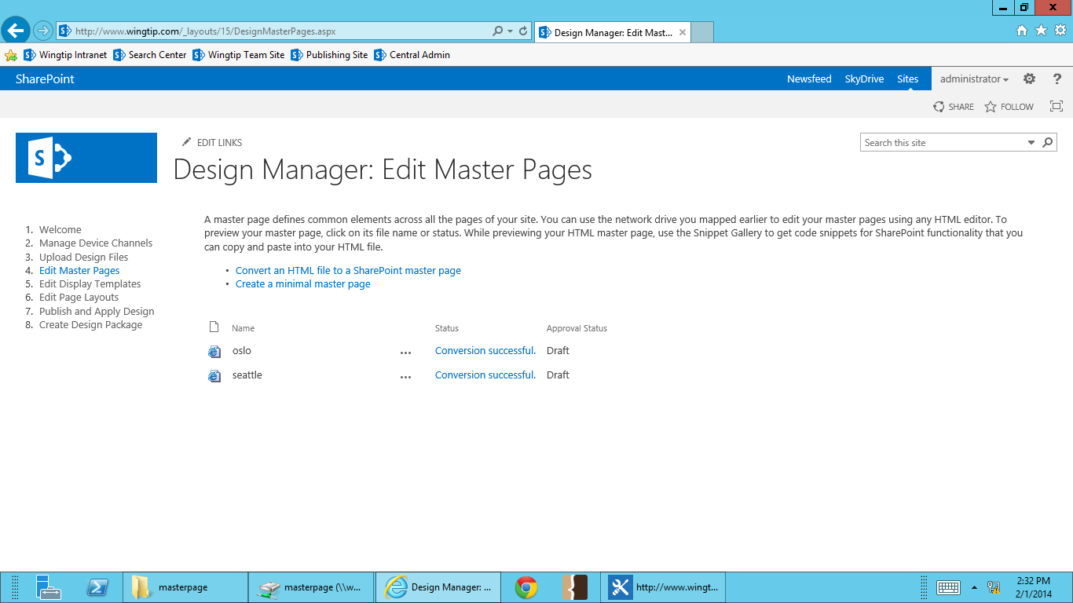

1. **Browse to you austin.html and select Insert.**

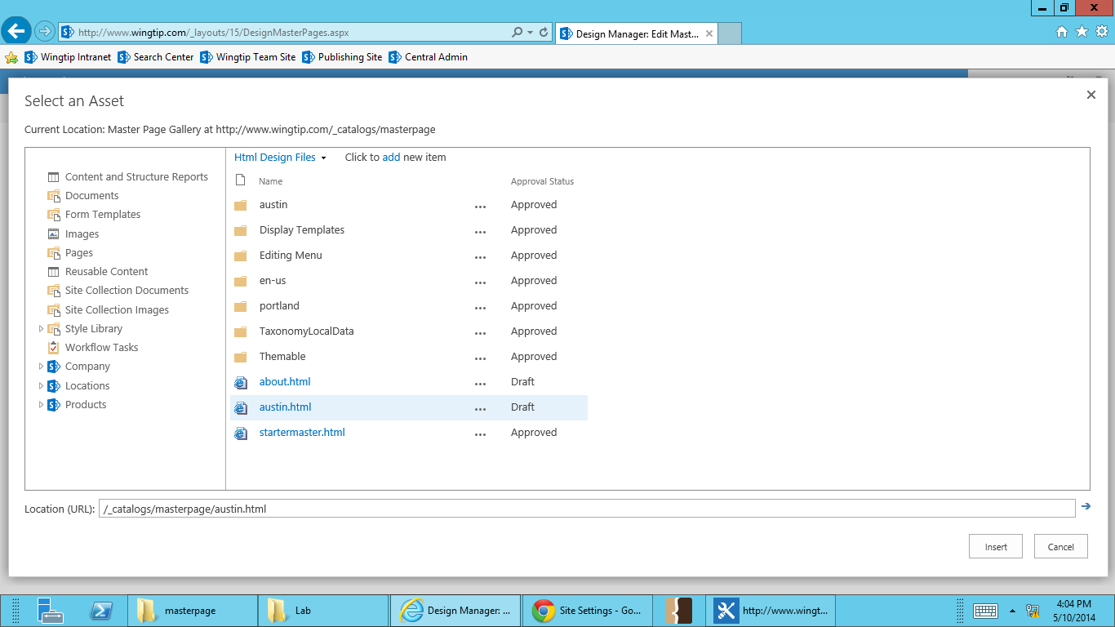

1. **After conversion, you will see austin.html in the master page list.**

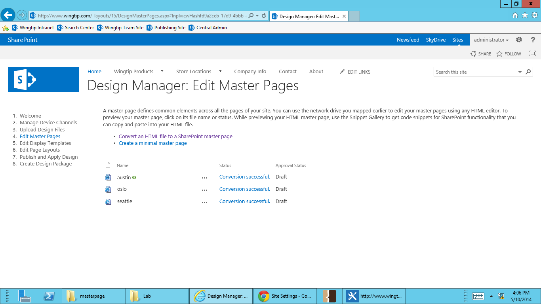

**The status will be “Conversion successful” if there were no problems. The status will say “Warnings and errors” if there were issues and the html could not be converted. If you get the status “Warnings and errors,” you can click on the status to find more information. SharePoint will let you know where the error in your code occurred that stopped the conversion from completing.**

### Exercise 4: Publish and Apply wingtip.master

**In this exercise you will publish wingtip.master and apply it to your site.**

1. Go to Wingtip’s publishing sites (<http://www.wingtip.com>) in your browser.
2. Select the **Site Actions** menu in the top right, and go to **Design Manager**.



1. **Select Step 7 – Publish and Apply Design.** 
2. **In Publish and Apply Design, you’ll be reminded that your master page needs to be published before it can be applied to a site. Select Go to the Master Page Gallery to publish your austin.master.**

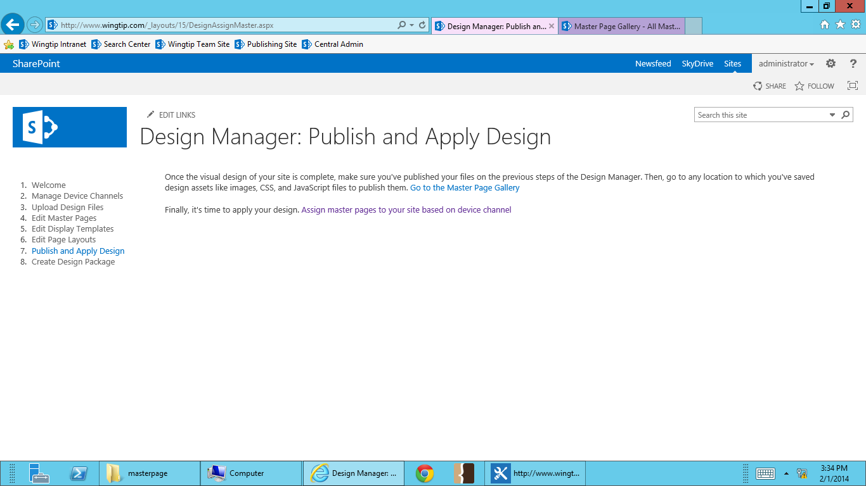

* 1. **The Master Page Gallery will open in another tab, so you can easily go back to Design Manager.**

1. **Select the dropdown menu for austin.html.**

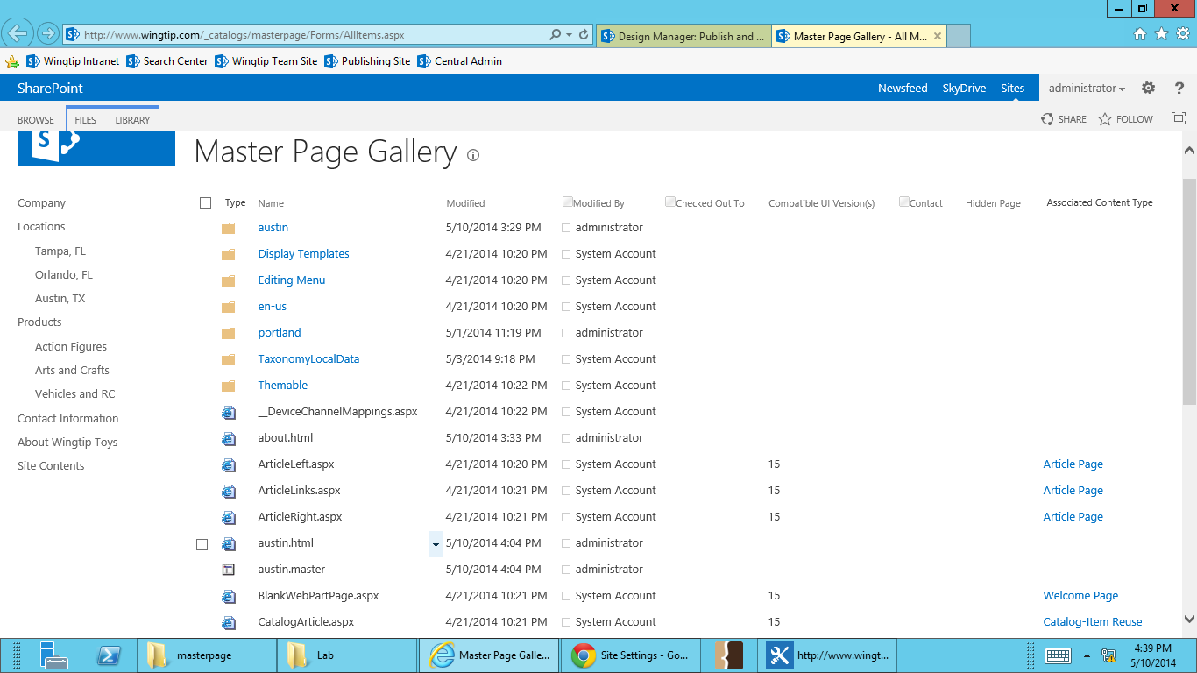

1. **From the dropdown menu, select Publish a Major Version.**

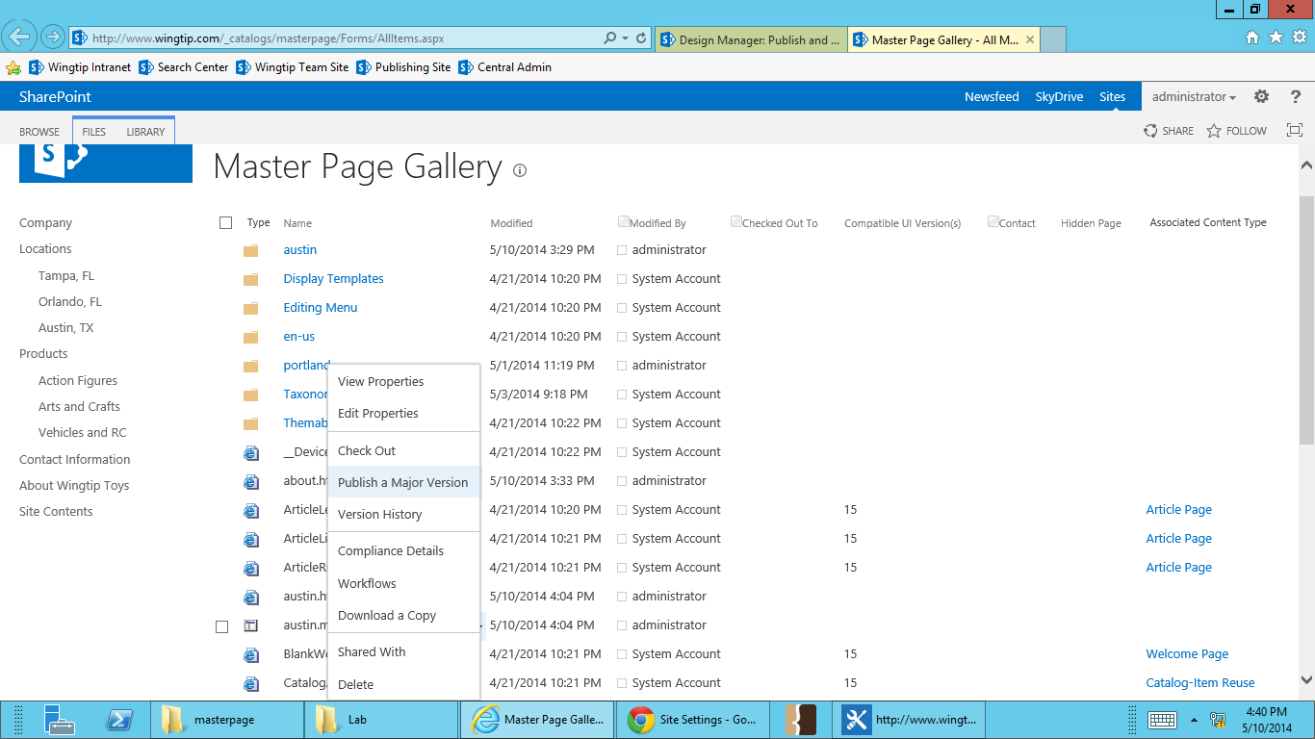

1. A dialogue box will show, giving you the option of adding comments for this publication. Add any comments and select **OK**, confirming you’d like to publish the master.

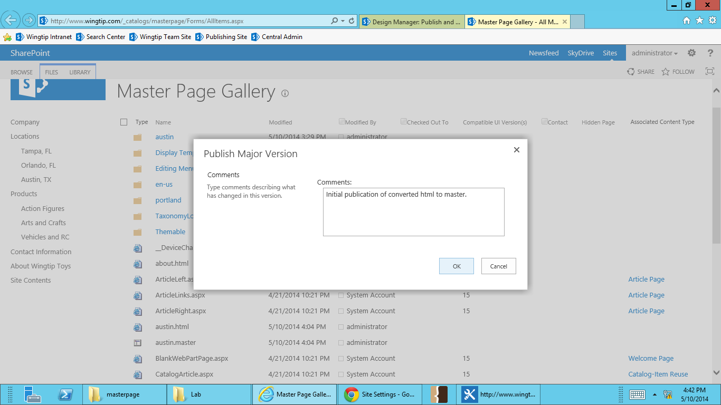

These comments will show up in the version history of your master page. While not required, it’s a good habit to get in to doing. It’s an easy way to track the changes you’ve made to your master page.

1. Go back to the Design Manager tab in your browser and select **Assign master pages to your site based on Device Channel**.



A dialogue box of the master page settings for the site will show. In the **Site Mater** Page settings, select **austin.master**. Be sure to select the, “Reset all subsites to inherit this site master page setting,” check box.

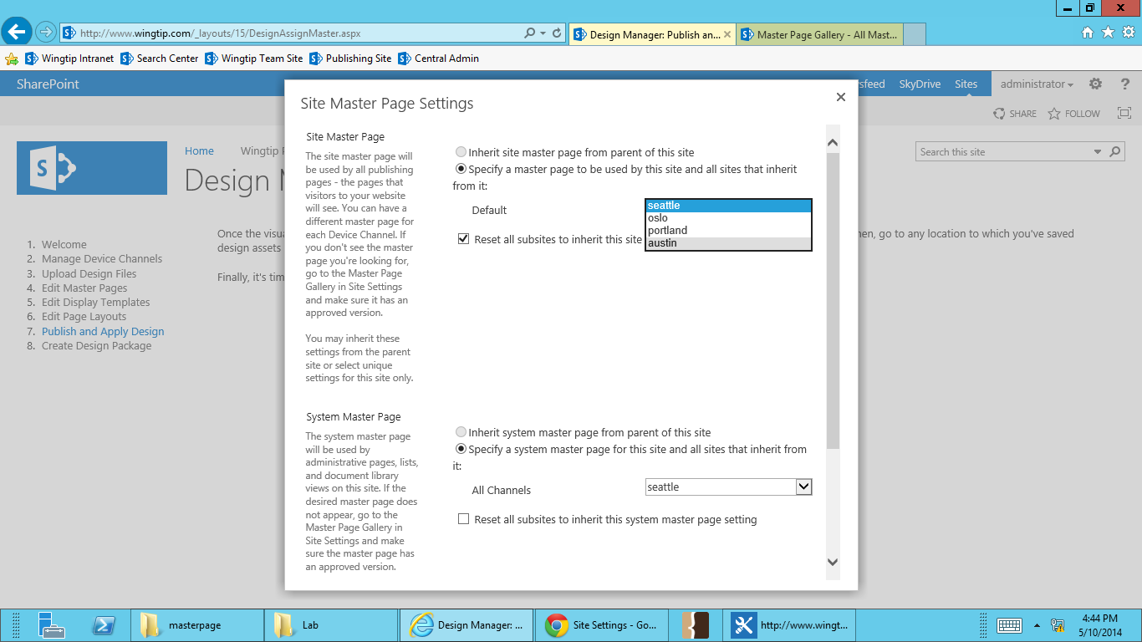

1. Scroll down in the open dialogue box and select **OK**.

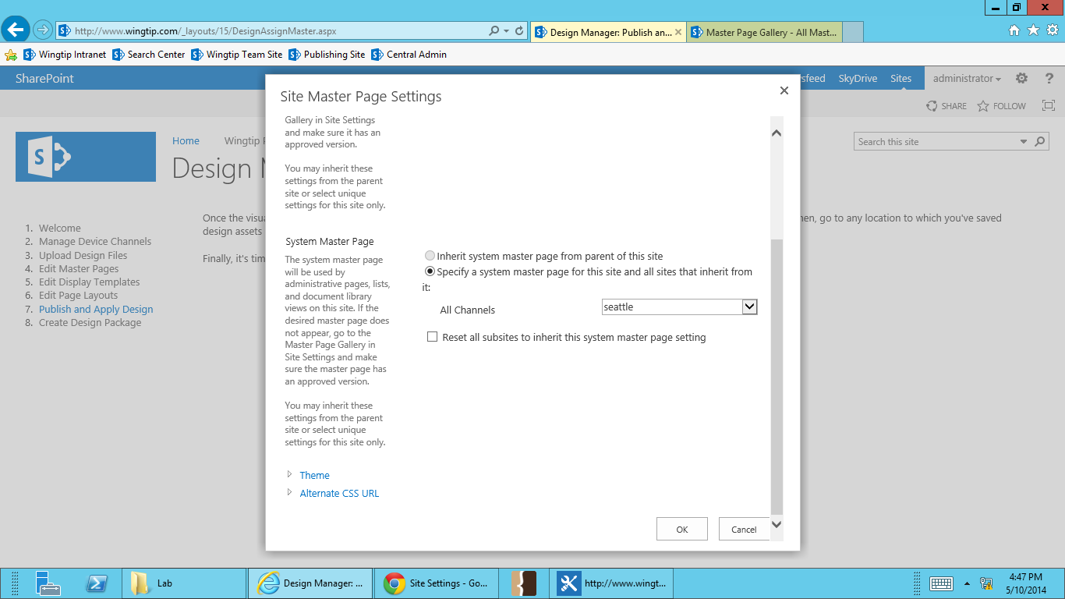

1. Click the SharePoint logo or “Home” link in the top left to go back to the root of your site. Your new design has been applied to your SharePoint publishing site.

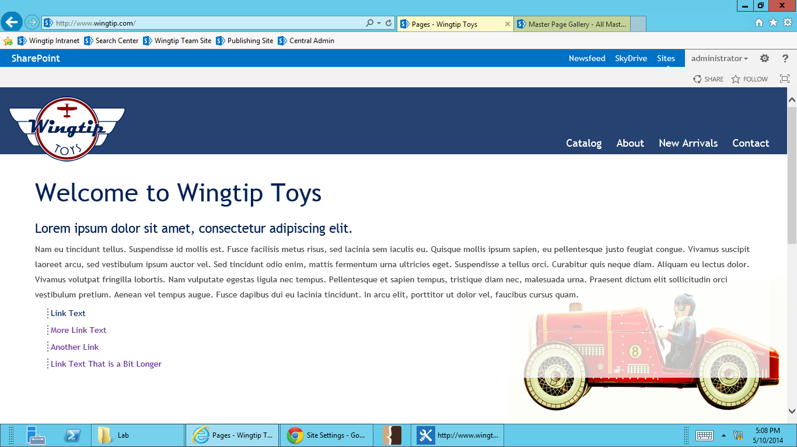

### Exercise 5: Adding a Snippet to a Master Page

**In this exercise you will add a snippet for the top navigation from the snippet page gallery to you austin master page.**

1. Go to Wingtip’s publishing sites (<http://www.wingtip.com>) in your browser.
2. Select the **Site Actions** menu in the top right, and go to **Design Manager**.

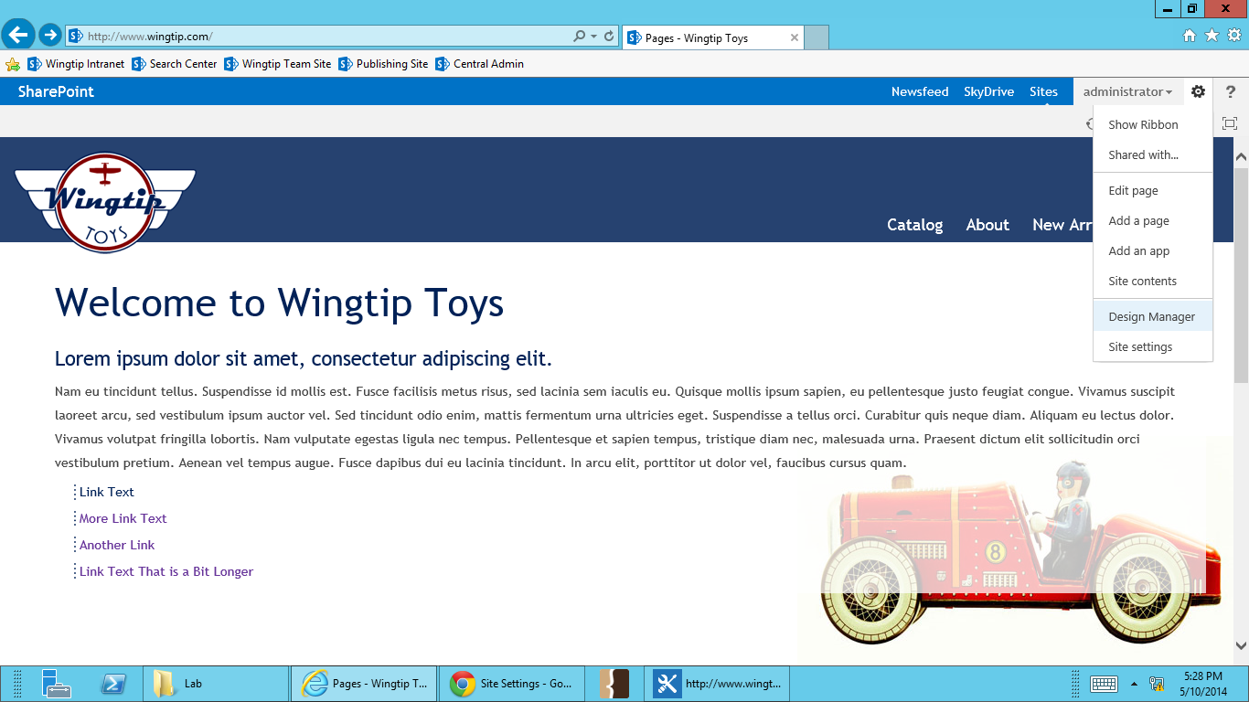

1. **Select Step 4 – Edit Master Pages.**



1. Select **austin** to open it in preview mode in the browser.

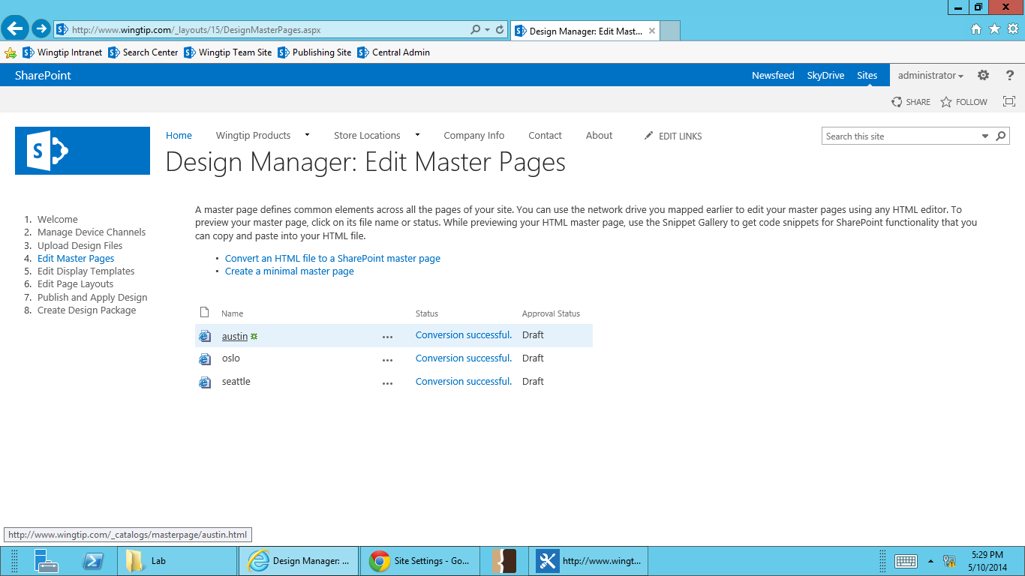

1. Select **Snippets** in at the top right of the page. The Snippet Gallery will open in a new tab.

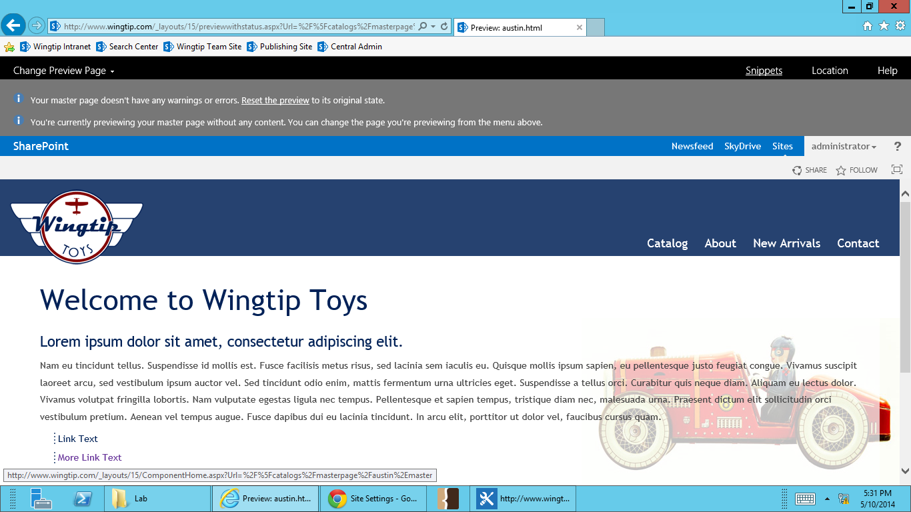

1. Select **Top Navigation** from the Snippet Gallery ribbon.

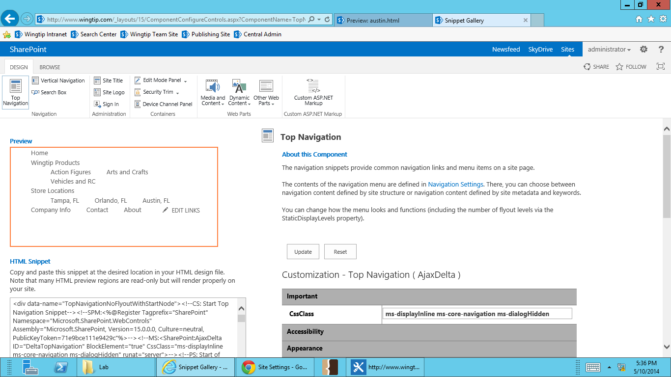

1. **Scroll down** till you see **Customization – Top Navigation (AspMenu)** in the Customization pane on the right. **Change** the Static Display Levels from **2 to 1**. This will set the top navigation to only display the first level of navigation.

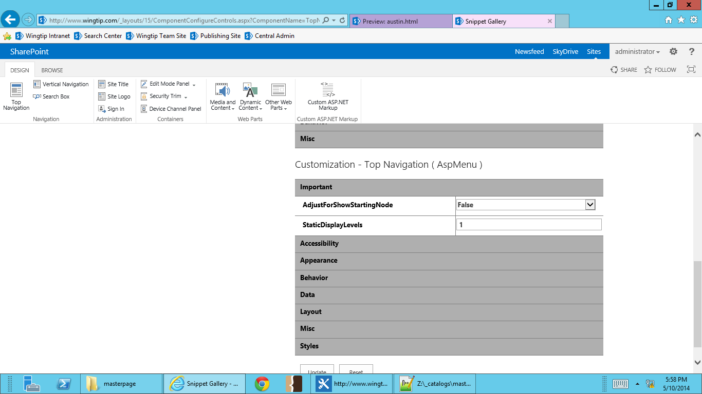

1. Still under Customization – Top Naviation (AspMenu), **Select Behavior** to open more top navigation display options.

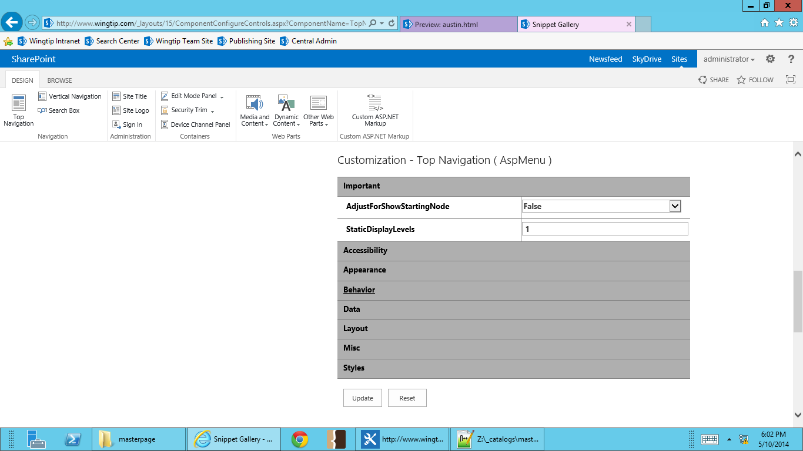

1. **Scroll down** till you see **MaximumDynamicDisplayLevels**. Change the number from **0 to 1**. This will set the top navigation to show one level of flyouts.

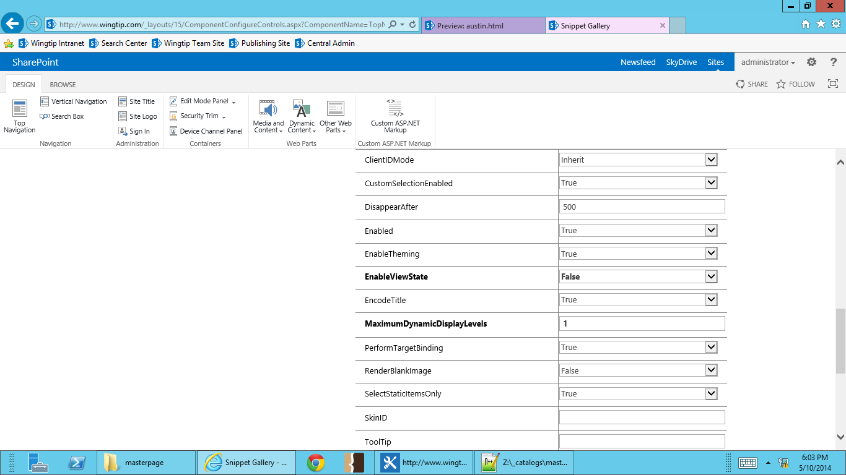

1. **Scroll down** to the bottom of the page till you see **Update** at the bottom of the customization pane. **Select Update**.

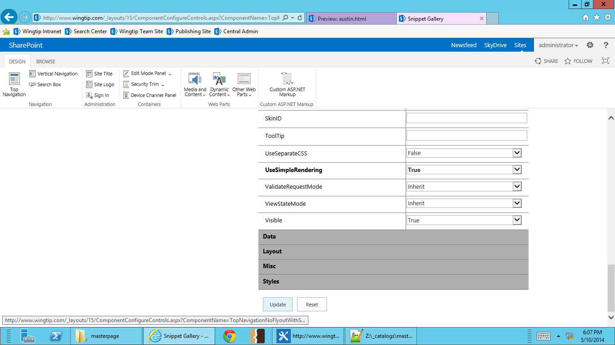

1. **Scroll up** till you see the **Copy to Clipboard** button below the HTML Snippet field and **select** **Copy to Clipboard**.

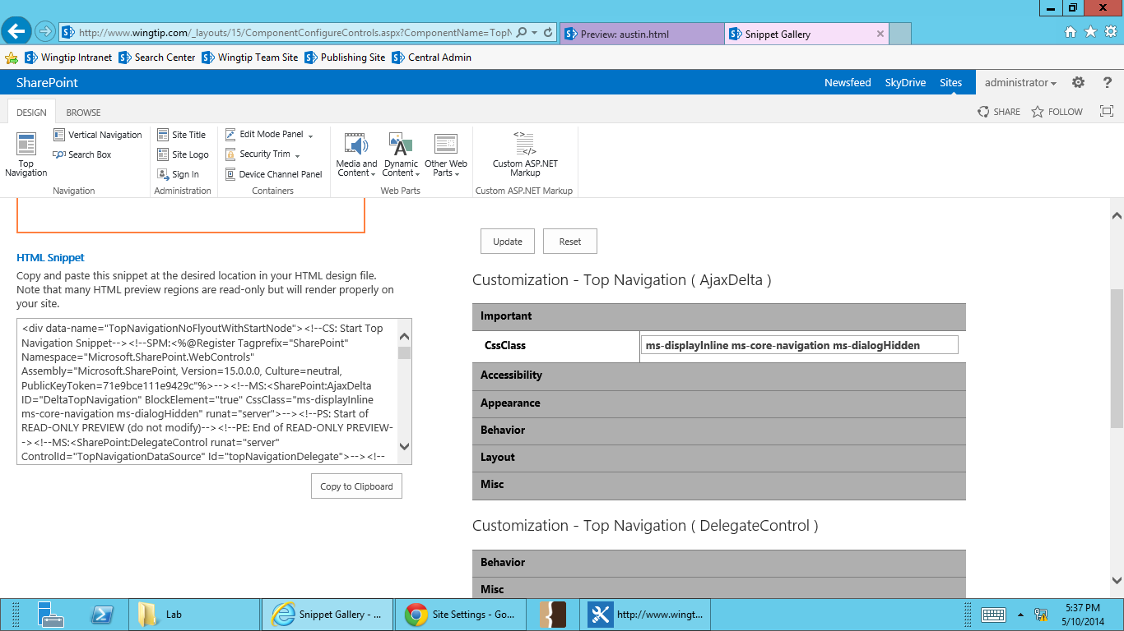

1. **Go do your desktop and open your mapped master page gallery drive.**



1. Right click on **austin.html** and select **Edit with Notepad++**.

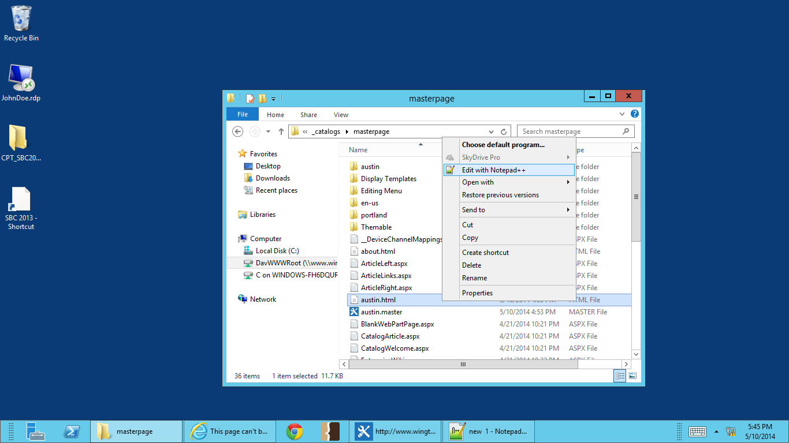

1. Scroll down to where the html navigation starts, line 111. **Delete** the contents within <div class=”navigation”>, lines 112-119.

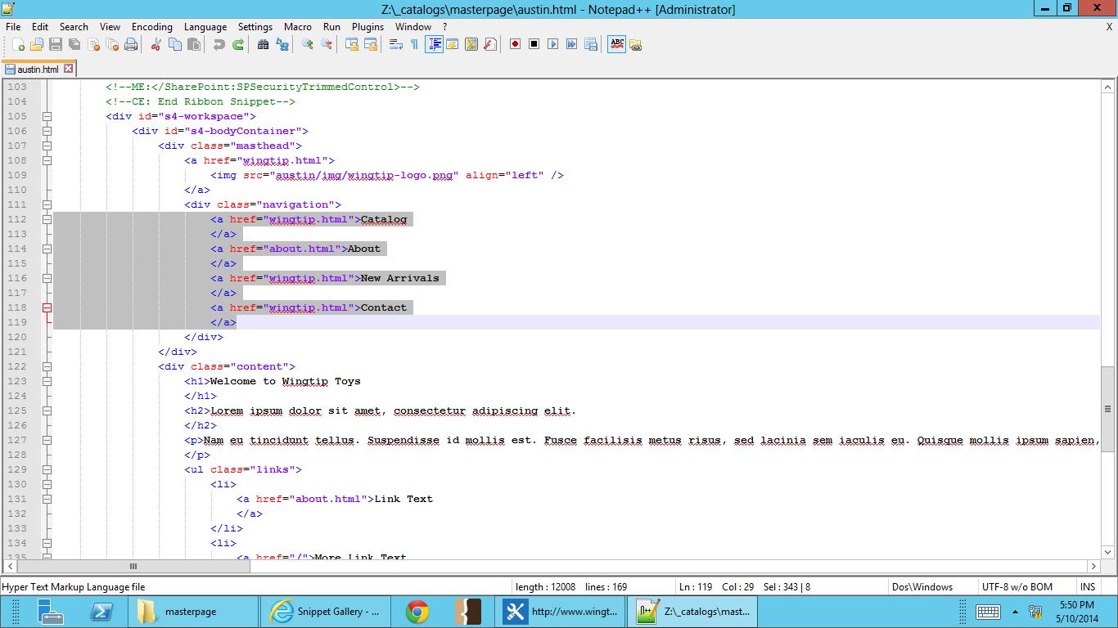

1. **Paste** the html snippet for the top navigation inside <div class=”navigation”>.

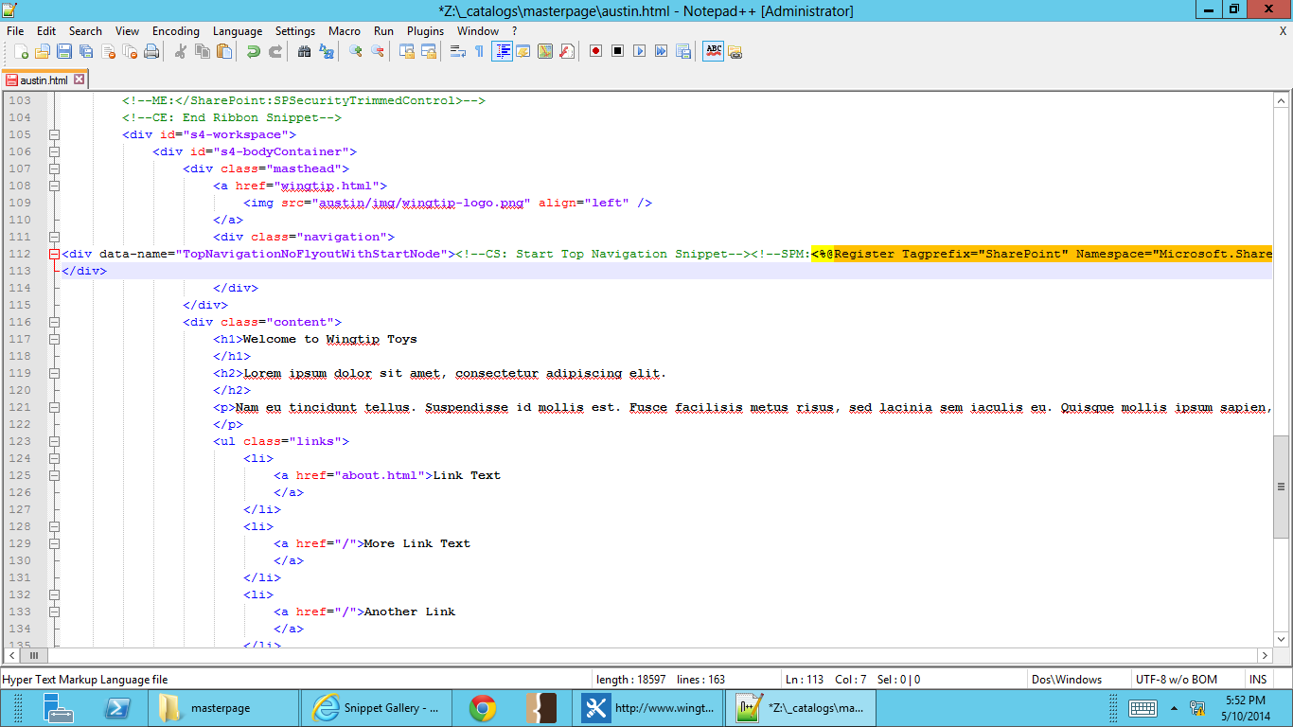

1. **Save** you changes.
2. Go to Wingtip’s publishing sites (<http://www.wingtip.com>) in your browser. You’ll see that the original HTML navigation has been replaced with the SharePoint top navigation.

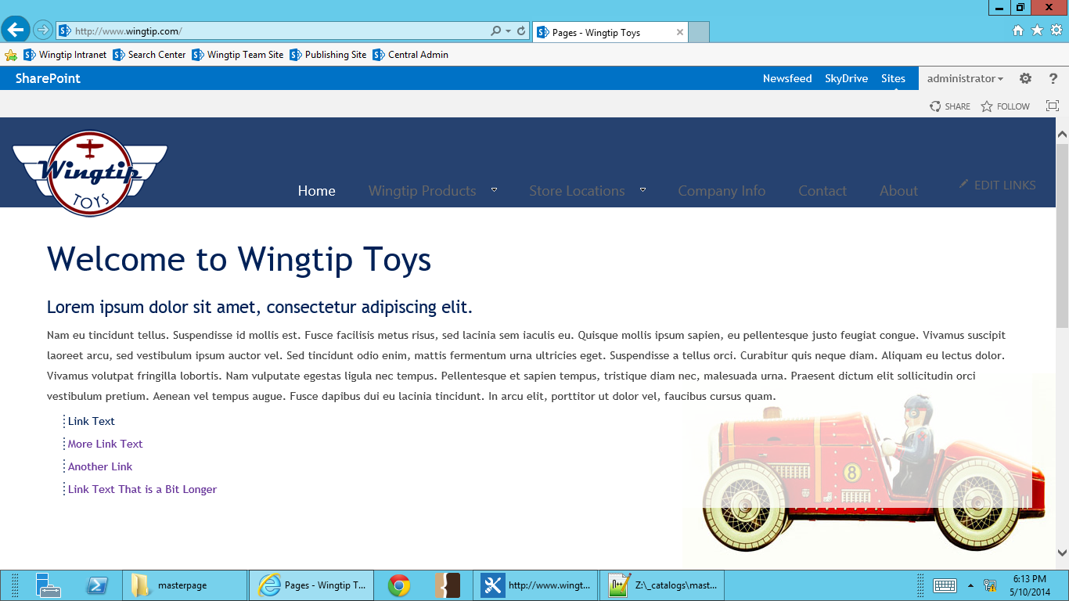

### Exercise 6: Creating a Design Package

**In this exercise you will create a design package containing your new master page.**

**\*Be aware that in the future before creating a Design Package, all your branding assets need to be published. In this exercise, we won’t go through the steps of publishing layouts, images, CSS, XSLT and display templates. This exercise is purely focused on creating a Design Package.**

1. Go to Wingtip’s publishing sites (<http://www.wingtip.com>) in browser.
2. Select the **Site Actions** menu in the top right, and go to **Design Manager**.

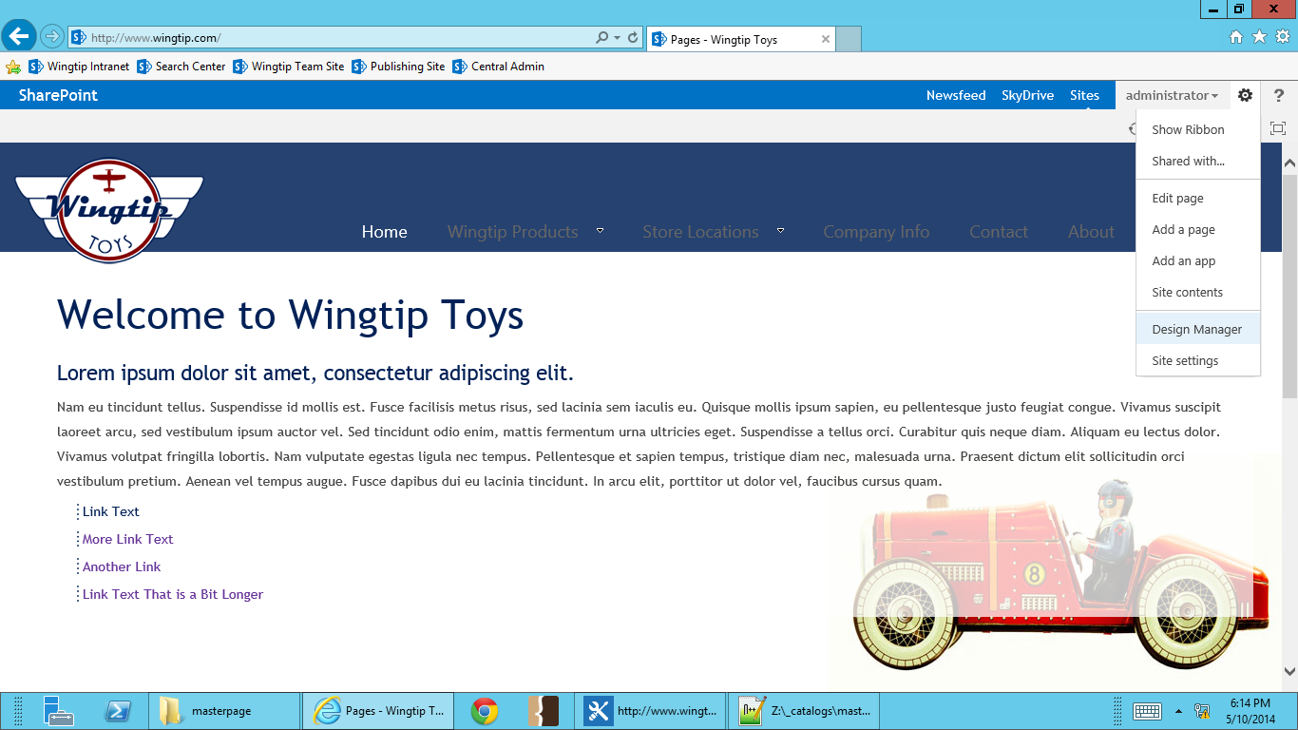

1. **Select 8 – Create Design Package.**

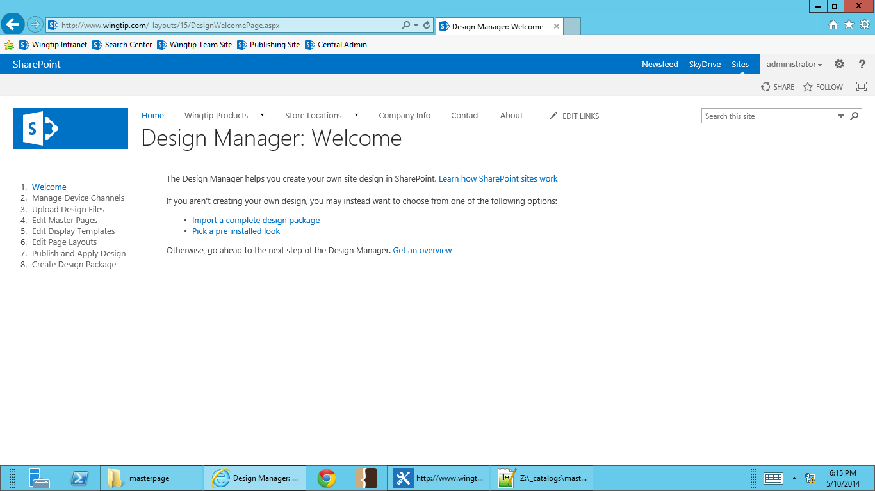

1. **Select Create.**

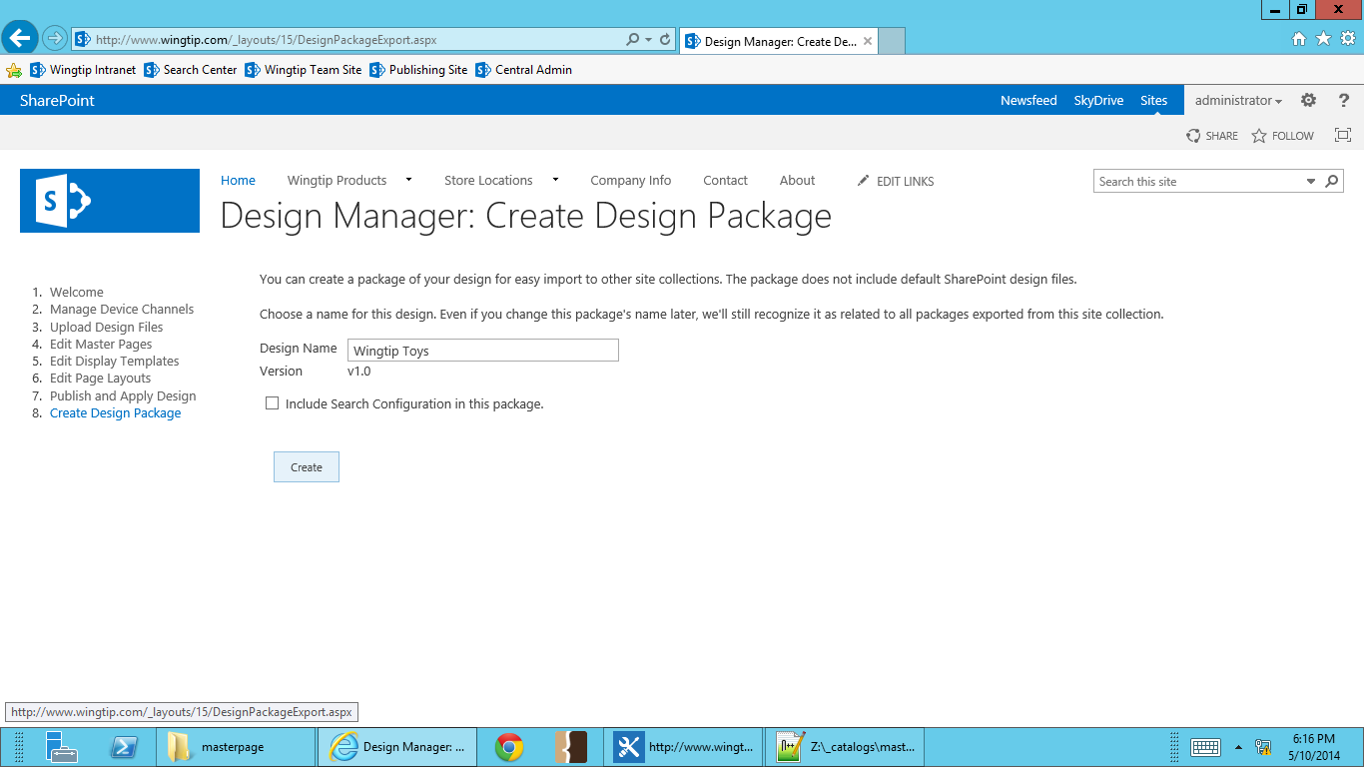

1. **After a minute, you will see that your package has been created, and you will be able to download it. Select Your package is ready. Click here to download.**

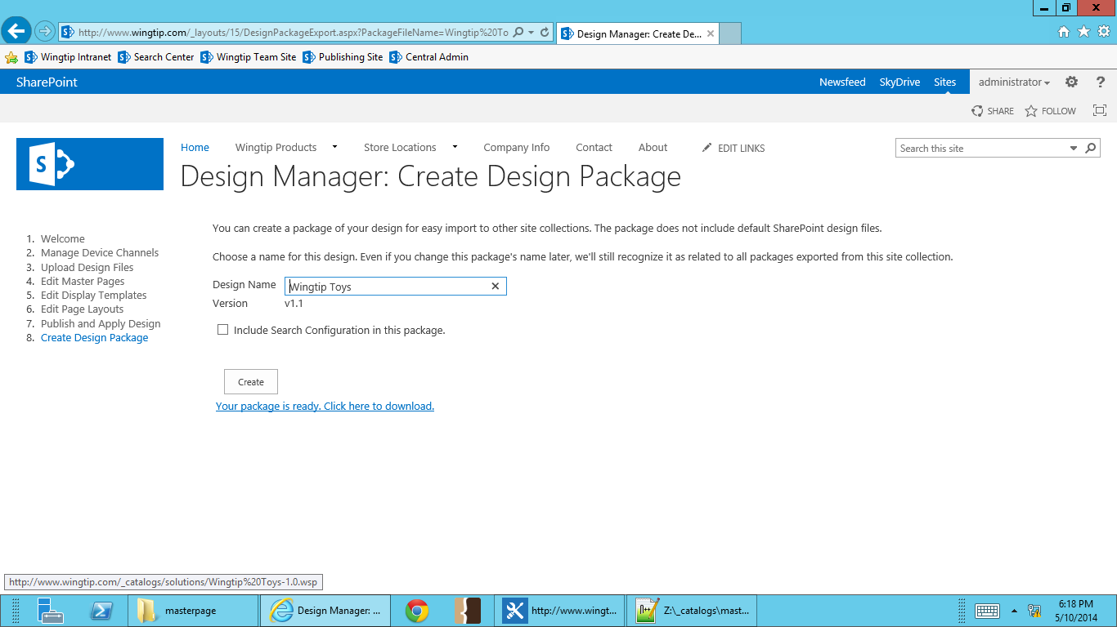

1. **Save your design package.**

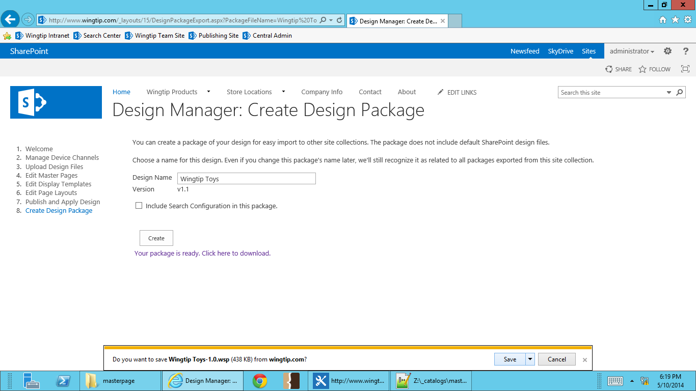

* 1. **Your Design Package has now been created and saved to your Downloads folder. It can now be uploaded to any SharePoint2013 site with Publishing Features activated.**

**You have now completed all the steps for this lab.**